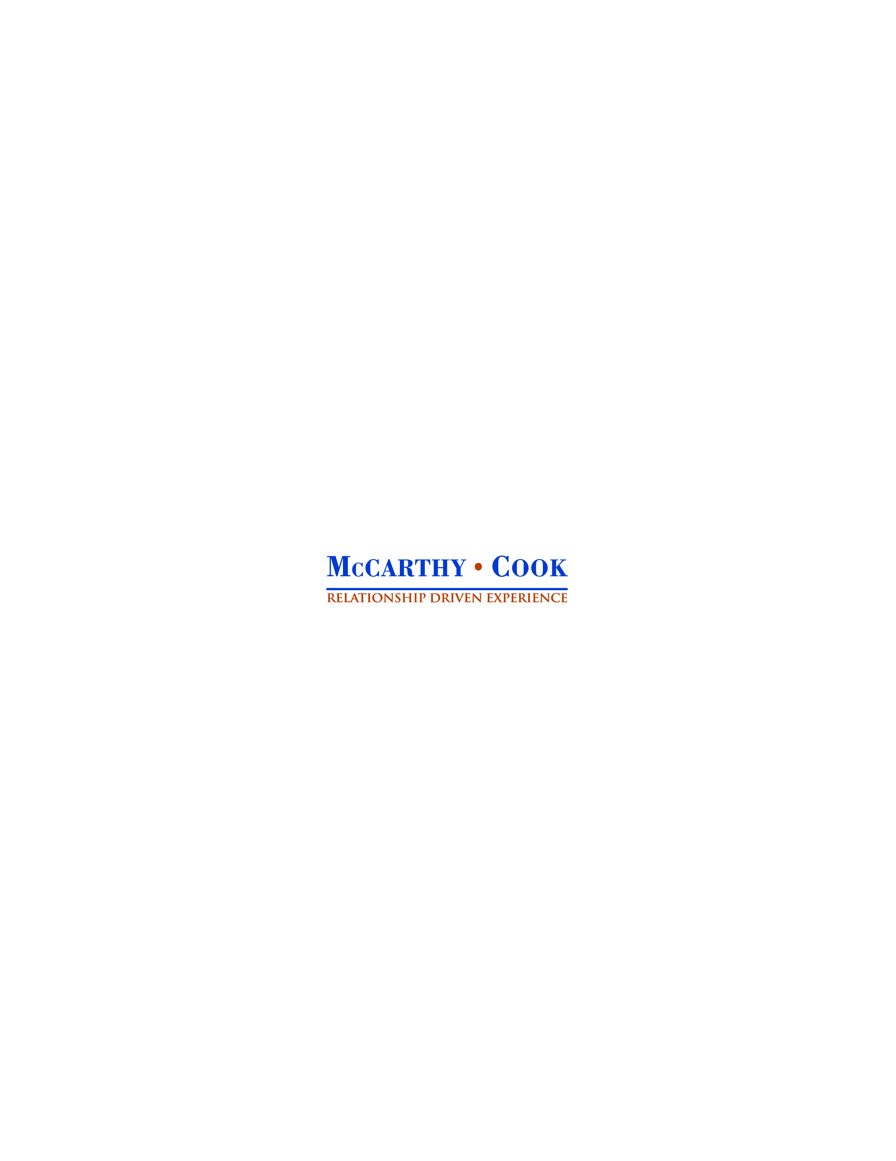

**Property Administrator**

Location: San Francisco, CA

**McCarthy Cook & Co., Team & Firm Culture**

McCarthy Cook & Co. is a privately held commercial real estate investor and manager with offices in San Francisco, Los Angeles, Orange County, San Diego and Phoenix. We are a passionate and collaborative team that invests in and manages creative office campuses and mixed-use developments. We bring a special blend of entrepreneurial zeal and institutional capabilities to investment underwriting, property management, leasing, and development/construction management. We envision and execute business plans for major institutional quality assets with plenty of opportunity for personal and professional growth for our enterprising, self-starting teammates.

**The Opportunity**

Join the McCarthy Cook Team as a Property Administrator working in our San Francisco office managing a one million sq. ft. creative office campus located in dynamic South of Market. This position requires excellent communication skills (both oral and written) and the ability to multi-task to manage deadlines. You must be a team player and pitch in whenever and wherever needed. Three years of commercial office property management experience is required. The Property Administrator will also support McCarthy Cook’s development/construction management department as needed.

*Essential Duties & Responsibilities include (Other duties may be assigned):*

* Responsible for lease administration activities including preparation, processing and maintenance of vendor purchase orders, preparation of contracts and agreements, certificate of insurance compliance for tenants & vendors, and maintenance of office files and documentation.
* Provide administrative support to Executive Vice President, including phone support, typing reports, distribution of correspondence and special projects.
* Assist and support Executive Vice President in the preparation of monthly construction draws and/or status reports for new development, major renovation and large tenant improvement projects and other duties that may be assigned.
* Respond to tenant requests, maintain effective ongoing tenant relationships and implement initiatives to promote the highest level of tenant satisfaction.
* Take initiative to identify customer needs and provide services to meet or exceed customer expectations. Follow-up on completed work orders with tenants to ensure work was completed and tenants are satisfied.
* Prepare and/or support bidding of building services and improvement projects. Support Senior Property Manager in the preparation and coordination of major bids, proposals, service contracts and tenant & building improvement construction projects.
* Work with Operations Manager and engineering department to maintain strict compliance of purchase order and vendor contract administration system.
* Oversee waste management program, identify ways to increase recycling/composting and reduce waste stream.
* Assist management team with preparation of monthly and quarterly reporting and annual budget.
* Perform/prepare monthly and ongoing property inspection reports.
* Support vendor relationships to ensure service expectations and contract obligations are met.
* Provide support for IT issues, copier, fax and printers and assist with lobby desk coverage.

*Essential Skills and Qualifications:*

* Bachelor degree
* A minimum of three years commercial property management experience
* General knowledge of building operations and management
* Excellent verbal and written skills with demonstrated ability to communicate effectively in person and by telephone, email and other written correspondence
* Must be highly organized and detail oriented, able to multi-task, meet deadlines and work under pressure while maintaining a professional attitude
* Demonstrated ability to management multiple tasks and priorities to conclusion
* Must have excellent customer service skills, ability to effectively respond to sensitive issues, complex inquires or customers complaints
* Must have good computer aptitude and strong skills including Microsoft Office (Word, Outlook, Excel, & PowerPoint), Adobe Acrobat & Illustrator

*To apply for this position:*

* Send resume and cover letter to imbedded in the email to: [gvp@mccarthycook.com](mailto:gvp@mccarthycook.com)
* Reference your email: Property Administrator Position

***McCarthy Cook & Co. offers competitive compensation including salary, bonus and medical insurance package and the benefit of working with a great team!. McCarthy Cook & Company is an Equal Opportunity Employer and an inspired place to work!***